Deep Griha Society

*“Empowerment of the marginalised through capacity building and sustainable rural and urban development programmes”*

**Quarterly Report April to June 2024**

**Key Advancements/Highlights Key Challenges faced**

**General Programme Updates**

**Aadhar Kendra Sponsorship Programme**

The Aadhar Kendra team grew this quarter. We now have a new English and Math teacher who will work out of the Ramtekdi centre and a new Supervisor who will work on getting new local sponsors on board to bring the number up from 198 sponsors for 262 children. New sponsors will help us to enroll the children in our waiting list as well.

This Quarter covers the end of the academic year, the summer break and the beginning of a new academic year for the children. In the summer break, the children had access to a few days of +hobby classes where fun activities and workshops were organised. We had seniors from the Vriddha Mitra programme conduct some sessions for the children in a wonderful cross programme activity. We are looking to increase interaction between the young people in our programmes with the elderly as we try to bridge the gap between generations.

The children’s height and weight were recorded and will be considered as we rework the meals that are provided. Based on feedback from parents we organised parent workshops in this quarter as well.

Sessions for the children covered self-awareness, good communication and practical life skills for personal and professional growth. A session focused on emotions was conducted where young people were introduced to identification, understanding, and healthy expression of emotions.

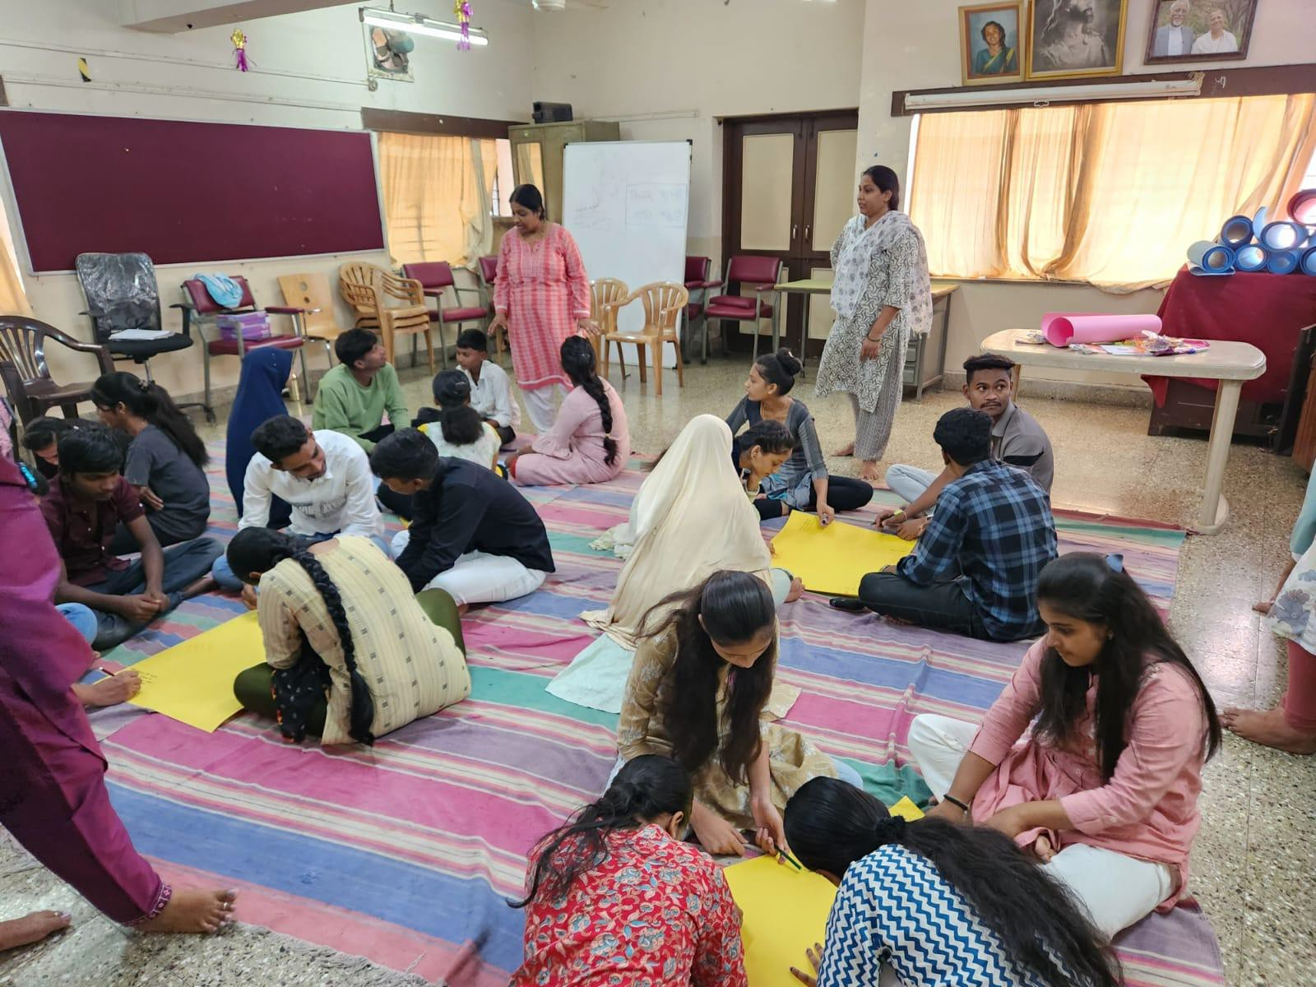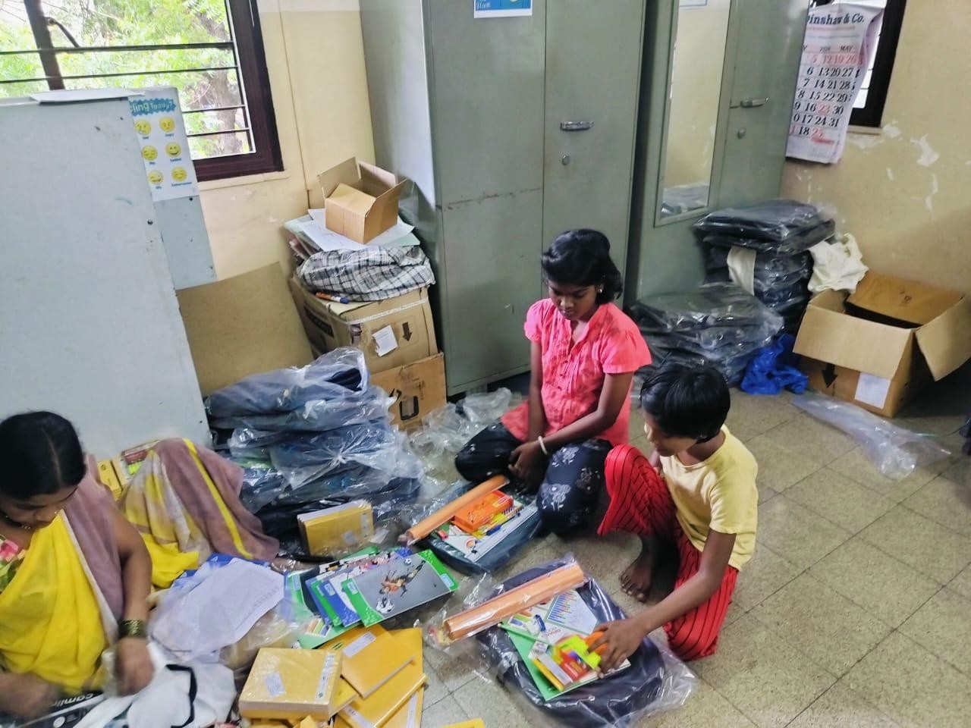This year we have started with regular field worker meetings with children at the three locations. Topics of discussion at these meetings range from studies, health, school performance and other support where needed. School material was distributed in this quarter - school bags, books, stationery, and uniforms.

# City of Child

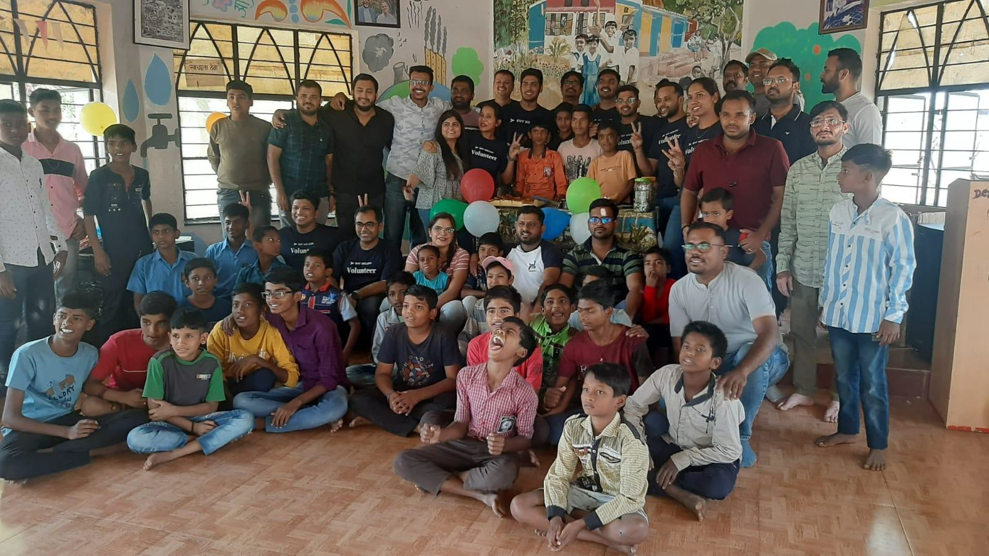

and activities.

Local support from individuals and companies for CoC has been growing over the years and this quarter has been no different. We received tables and stools for the dining room and a big water cooler as donations-in-kind from a

company. This means the children don’t sit on the floor for meal times anymore and they are very happy to have access to cold drinking water, especially through the summer. Apart from these large donations, groceries, fruit, and snack donations continue. We had employees from BNY celebrate the April birthdays with the children and they organised a lot of fun games

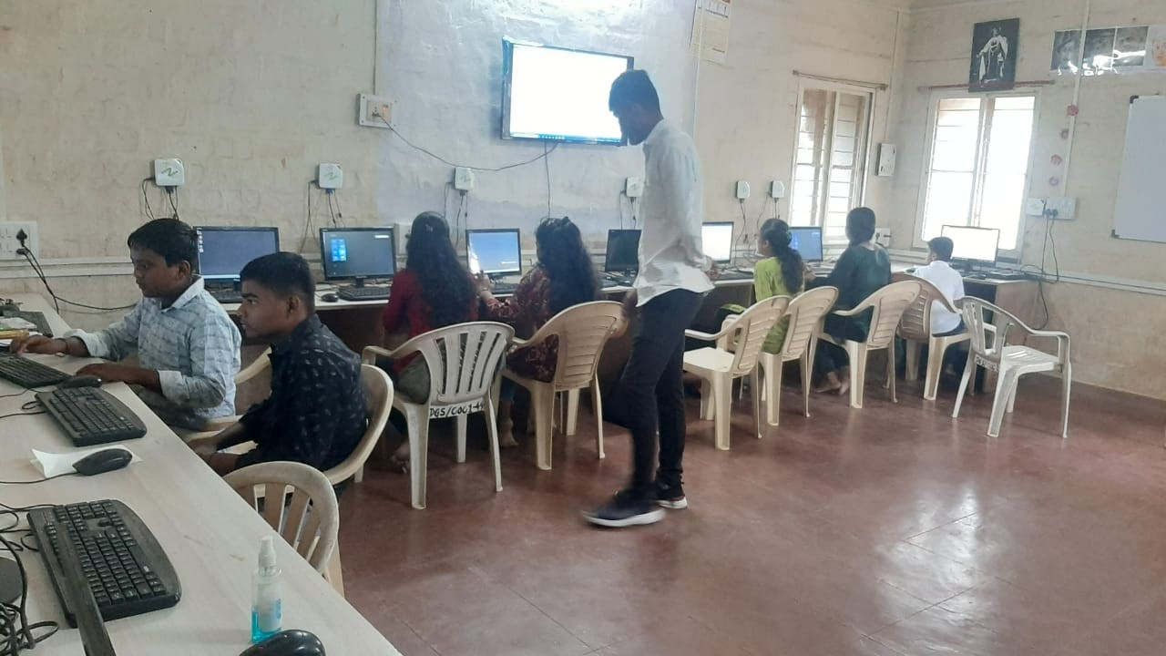In this quarter, we finally started computer classes for children and adults from Kasurdi village. Our biggest challenge was to find a computer teacher for the classes in Kasurdi, we now have a resident teacher. The teacher conducts classes for the village school for a few hours, then classes for individuals from in and around Kasurdi village, and finally for the children at CoC. We have 43 individuals from outside of CoC attending classes and the 44 young boys currently at CoC taking the total number of students to 87.

The counsellor sessions are back after the summer break, and they will be reviewing the Individual Development Plans that were made last year. Before the summer break, the counsellors conducted aptitude tests for children from Grades 9 and 10, to help them decide what they would like to choose for further studies after they finish school.

Agriculture

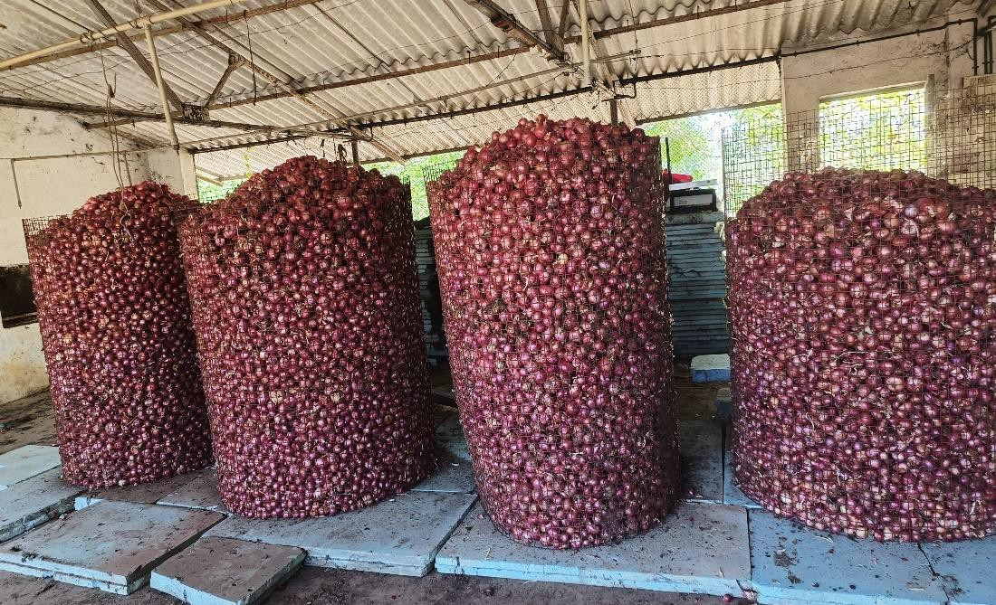We harvested 2,956 kg (6,517 lbs) onions in this quarter. Most of them were stored for use at the City of Child and the excess was sent to the urban centres to be used for meal prep.

The polyhouse continues to provide vegetables for the kitchen and this quarter produced:

|  |  |  |
| --- | --- | --- |
| Pumpkin | 11kg | 24.25Lbs |
| Spinach | 32 gaddi | 32 bunches |
| Bottle gourd | 12kg | 26.45 Lbs |
| Eggplant | 3kg | 6.6 Lbs |
| Tomatoes | 11kg | 24.25Lbs |
| Chillies | 2kg | 4.4Lbs |
| Cabbage | 2kg | 4.4Lbs |

# Deep Griha Academy

Deep Griha Academy has been focused on helping children cover learning gaps over the last few years. Virtual classes and no classes for some students over the lockdown period really affected what they knew and retained. The teachers work on diagnostic tests for the children at the beginning of the year so the teacher can plan lessons based on the varying needs of the classroom. The summer training for the teachers revolved around diagnostic tests and how to get the most out of them.

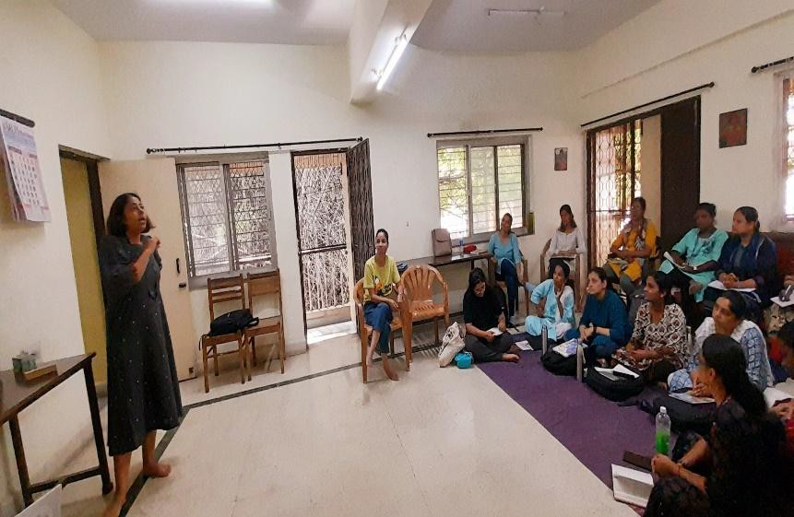

The numbers at school are dropping and not going up because of a Government permission that we haven’t received. The administrative team has been following up with the respective department and we hope to have a solution this year. We currently have 190 students enrolled at school.

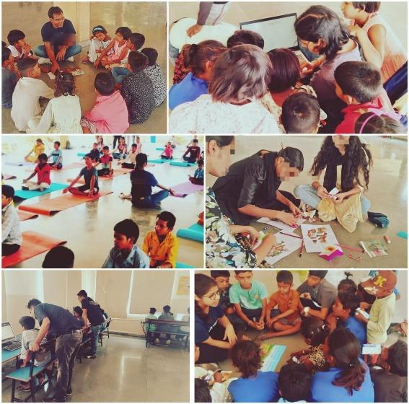

School has had regular community outreach over the months. We have been visiting two local government schools regularly for computer and language enrichment classes. The idea is to ensure access to quality education for all children, whether they are enrolled at DGA or not.

A two day summer activity camp was organised during the school holidays for children residing around the school.

The school also organised a Gynaec camp for girls and women from the community, with a plan to organise follow up camps for the women. The monthly Dental camps stopped for the summer break and will restart soon.

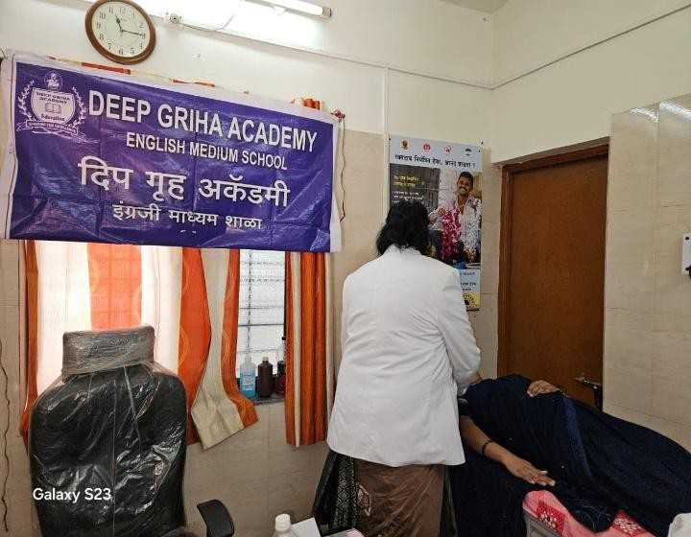

The school has a special needs educator who works with students with special learning needs and is using tools to help students with behavioural issues as well. The teachers have seen a positive response to the peer learning initiative, where students are responsible for each other’s learning.

Activities to ensure a healthy mind and body, celebration of environment day and life skills training are small steps in ensuring that we facilitate holistic learning and are preparing the children to be thoughtful, productive and environmentally conscious citizens of the world.

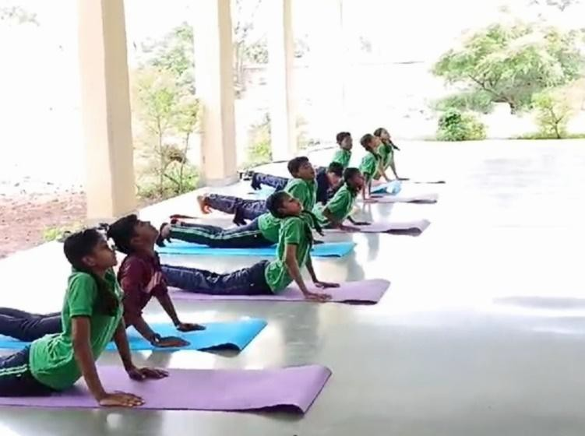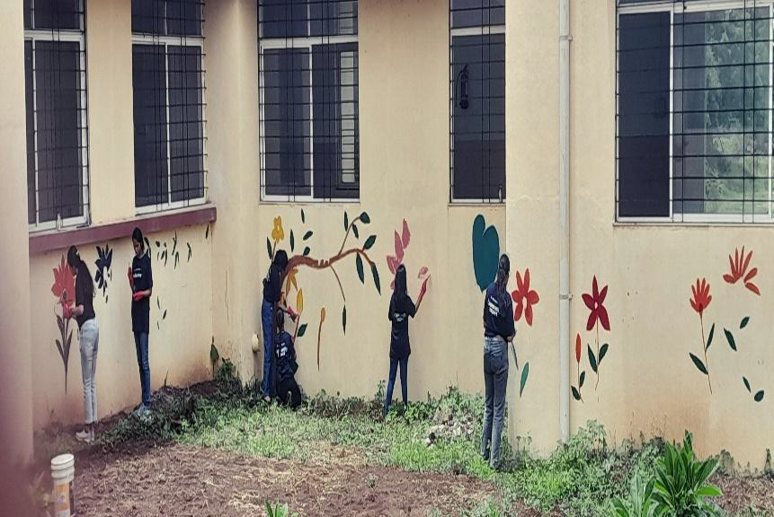

# Healthy Ageing

The Senior Citizen Programme is focused on helping participants get their documentation in order to access various Government services. The ongoing activities have continued through the quarter, here is a snapshot of numbers reached:

1. Total elderly – 4287
2. Total Home visit - 13956
3. Total Community Meetings - 86
4. Total attendees – 2591
5. Total OPD– 60
6. Total eye checkup camps – 16 Total elderly at the camp – 674 Total eye surgery – 332.
7. Total Social Security Sch - 2247

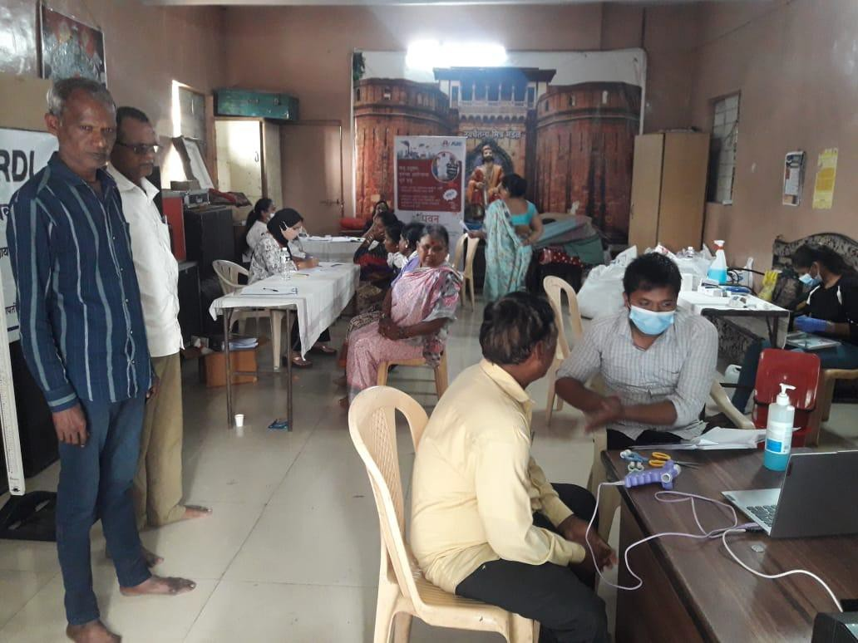 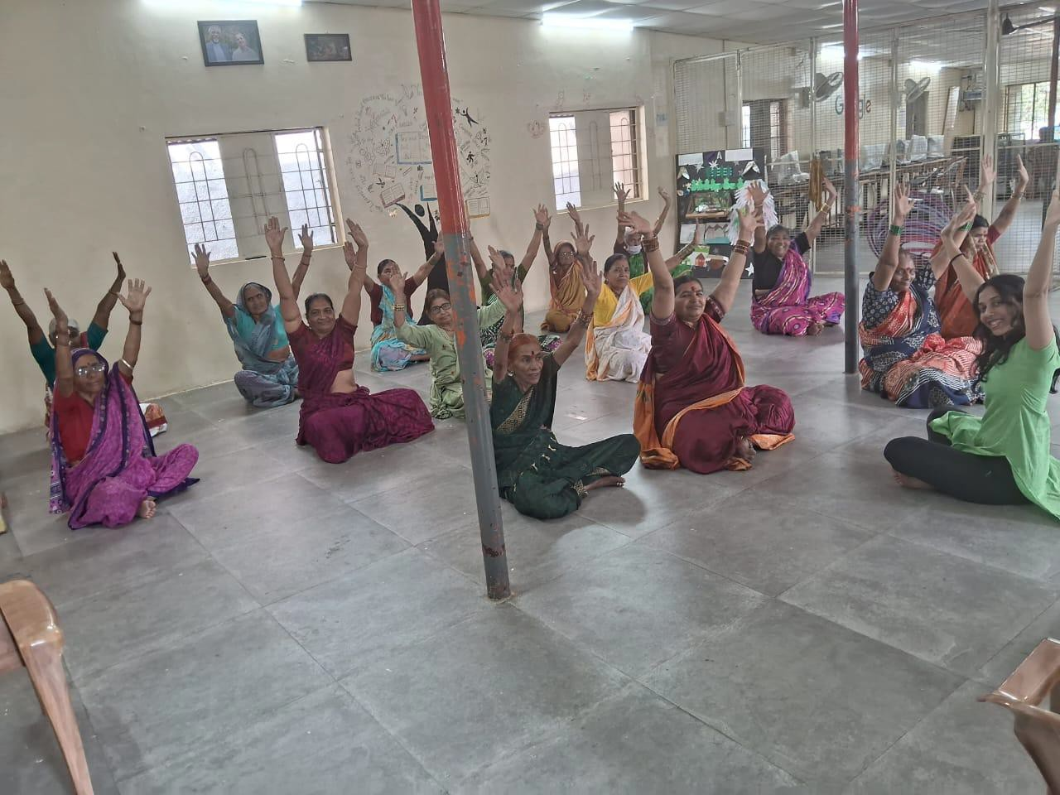

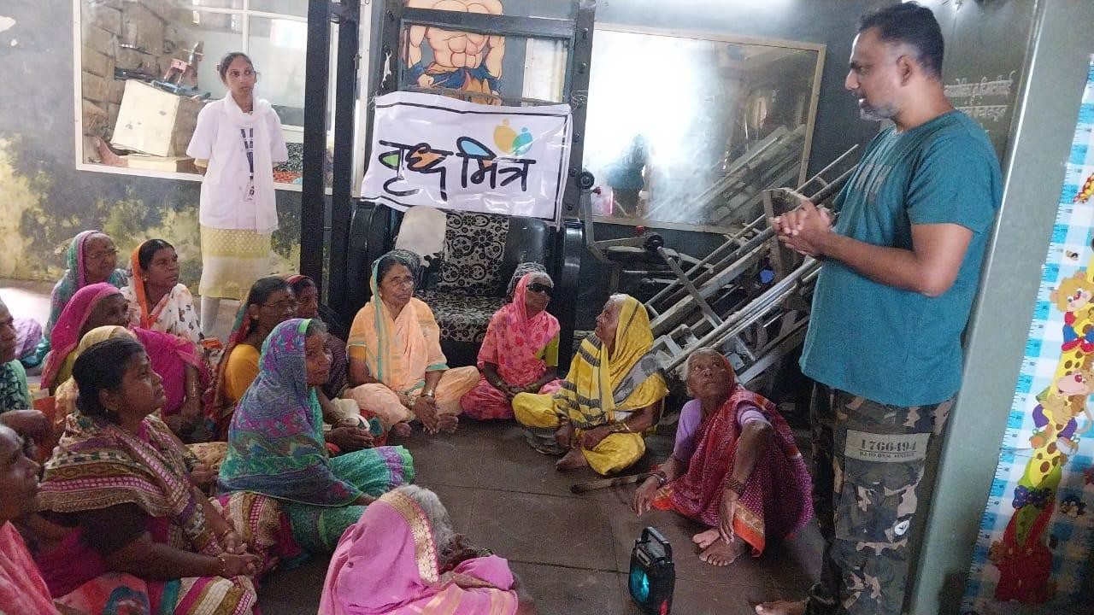Dance therapy classes were on a break for the summer but the healthcare camps and follow up continued. Social Scheme camps continued to ensure that people had the documentation needed to access government social services available to the Ajjis and Ajobas.

This programme reaches out to local donors for donations in kind for the grocery that provides daily meals, for medication distributed during the general check-up and Doctor consultation, and for the assistive devices needed by Ajjis and Ajobas. We have a lot of partners that come through for various activities including meditation sessions, grocery distribution for individuals, legal aid services for abuse faced by the elderly and of course partners for health camps.

# Income Generation Programme (IGP) - Asimit (Without boundary)

The Asimit project continues to grow with 18 new women signing up for the computer classes in

the quarter. The number of tiffins/lunch boxes provided per quarter went from 4487 to 4721. Through this quarter Asimit organised Financial Literacy Training for the staff as well as women from the community. These sessions helped women understand income, money and savings better.

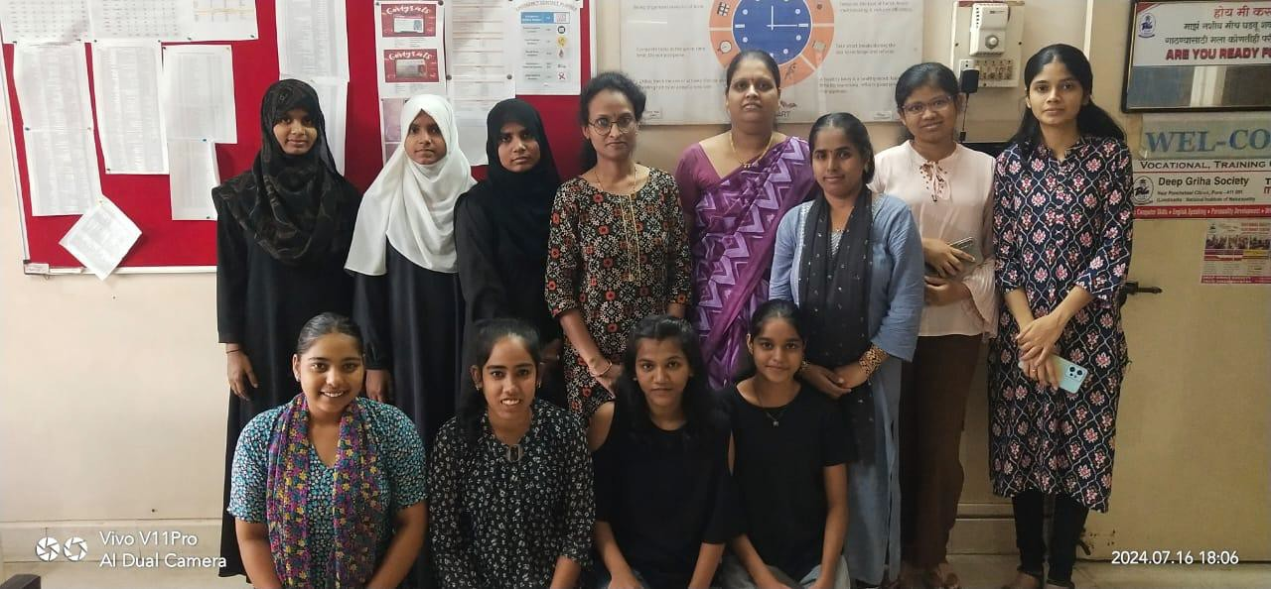

Through the summer the women made their own curry masalas to cut costs of buying readymade masalas and it has affected the taste of the food too, making it much better. The women enrolled with Asimit are primarily women who haven’t stepped out of the house before and to see them grow and thrive has been a pleasure.

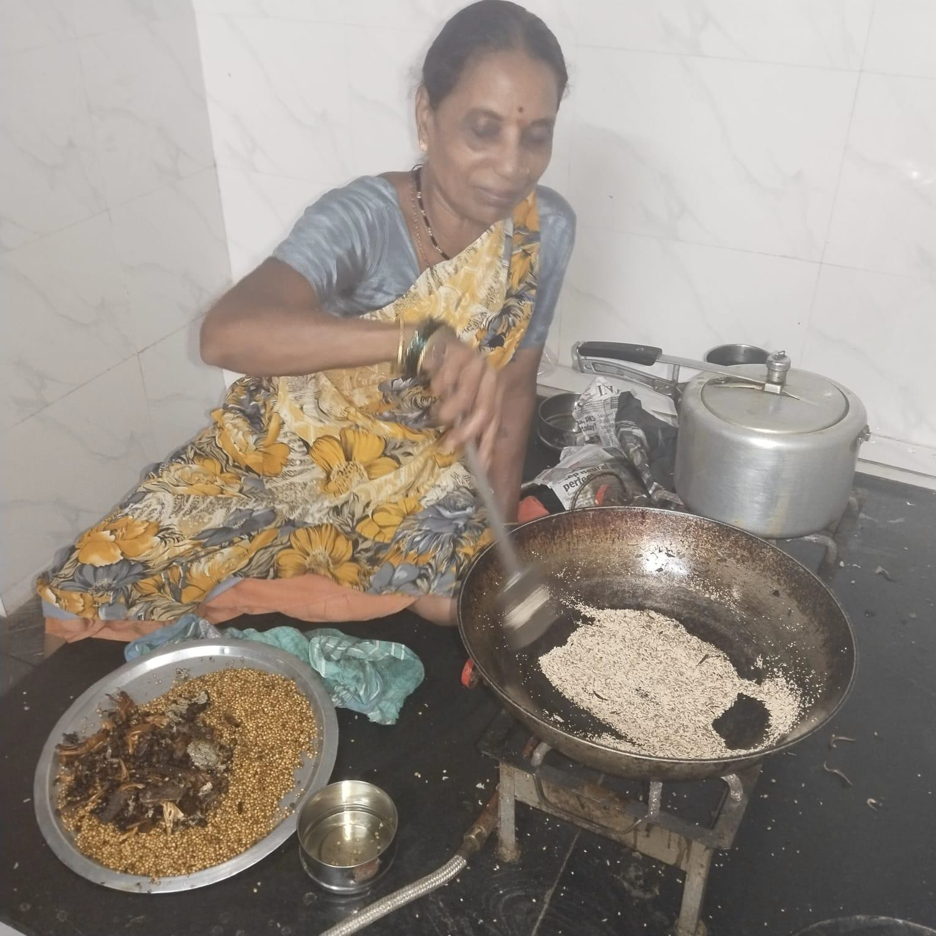

# Tech SMART Centre, Gokhale Nagar

The Tech SMART classes have trained 105 students in the first quarter. The placement percentage for last year has reached 70% which was the target placement percentage.

As an inclusive centre, we enrol students with hearing impairment, a facilitator who is fluent in sign language is available to assist the students. This year we have sponsorship for 60 students with hearing impairment and are excited to fulfil this new target.

Apart from Computers and language training, we ensure the students are prepared for the workplace through other soft skill development. Exposure visits, mock interviews, and celebrations are part of the course to ensure the students are as prepared as they can be for their first job.

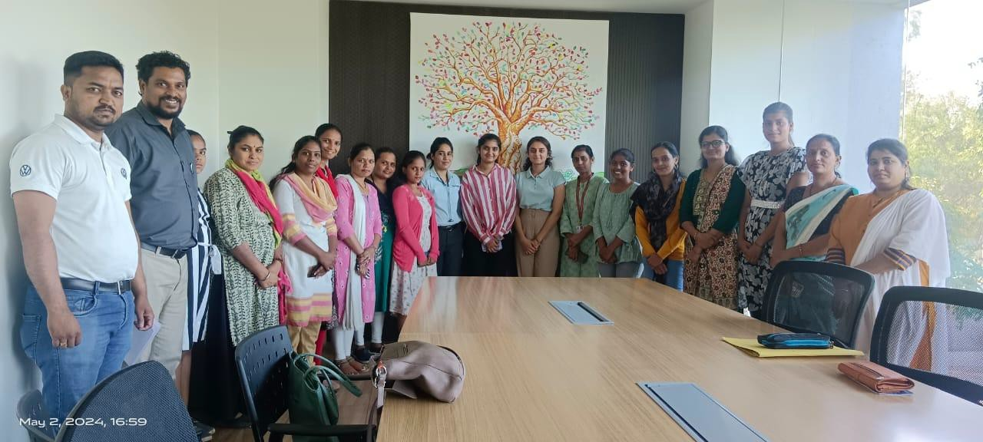Training young women to be part of the Auto Industry, conducted technical training at an Automotive Company where our role was to bring spoken English and basic computers and workplace readiness.

# CHW Research Study

After consistent follow up with the PMC - Pune Municipal Corporation, we were able to begin the study in June. After months of intensive training, the CHWs were more than ready to begin data collection. Months of training also meant that everyone was more than ready for all the aspects of data collection.

So far 12 CHWs - Community Health Workers are working out of as many low-income communities in Pune. Identifying pregnant women, getting consent conducting OGTT testing and so far we have administered 106 OGTTS (Oral Glucose Tolerance Tests) with 37 women testing positive for GDM, a much higher prevalence than anticipated.

# Dream Proposals

Although there are many proposals that we would like to work on, at this point we are prioritising building our corpus fund. A handful of our previous dream proposals involved renovations and upgrading infrastructure and the facilities. If we are able to build the corpus, we will be able to cover these expenses. We have set aside a small amount as and when possible, based on calculations we need approximately USD 800,000 more to reach our goal.

**Areas of Greatest Need/General Donations**