Newsletter #1
A Time to Remember A Time to Move Forward
For the whole world, the year 2023 has been a year of uncertainty, but also oﬀering exciting new possibilities. This year, Deep Griha Society (DGS) Pune, has embraced this opportunity to change and is evaluating all their programing and ways of working to fit the new needs of the local community. Our goal as Deep Griha USA (DGUSA) has been to help DGS in their embrace of change and achieve their mission of “Empowerment of the marginalized through capacity building, and sustainable rural and urban development and programs.”
As part of this mission, in 2022, we at Deep Griha USA (DGUSA) along with our Deep Griha partners from across the pond, Friends of Deep Griha Society UK (FoDGS), formed a Strategy and Communications group. This group continues to meet with Ashlesha on a quarterly basis to support her vision for DGS Pune. The quarterly reports generated from each of these meetings highlight the status of key DG programs and are shared via DGUSA E-mail or Snail-mail newsletters.

Remembrance
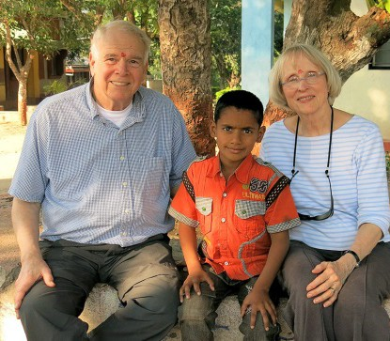
This year we remember a Friend, Mentor and Visionary of the Deep Griha USA organization. Sandy Wood left a tremendous mark on the Columbus, Ohio Short North community he loved, and for us, he provided the heart and soul of the Deep Griha USA organization. His passion and vision for this community and organization will be forever engrained in our DNA.
The Wood family is interested in designating funds for projects that will most directly impact the lives of children. Ashlesha provided a wish list of initiatives that are currently being prioritized by DGS, and Barbara Wood selected Counseling and Agriculture as the two initiatives she believes will reflect Sandy’s wishes.
The following is an overview of each initiative.

Counseling
Previously, counseling was provided for the Aadhar Kendra Sponsorship students by four counsellors. However, two resigned and it has been diﬃcult to hire replacements due to salary constraints. The two remaining counselors were stretched thin between three urban centers and the City of Child.
Thanks to the Sandy Wood Memorial Fund the new academic year started with support from Ms. Nidhi who is a part- time remedial teacher at Deep Griha Academy but stays at the City of Child for 2-3 evenings every week. Ms. Nidhi’s counseling background is particularly useful to have on the team a few days a week as there have been multiple episodes of diﬃcult behavior. They were also able to hire a team of counsellors who travel to CoC for 3 Saturdays a month to work on IDPs (Individual Development Plan). The team has conducted a baseline assessment of the children and will follow through with group sessions and activities that will best support the children. These counseling initiatives help DGS provide a safe, healthy space for the young children at CoC. We have seen changes in the children and we will now have documentation to support the observations.

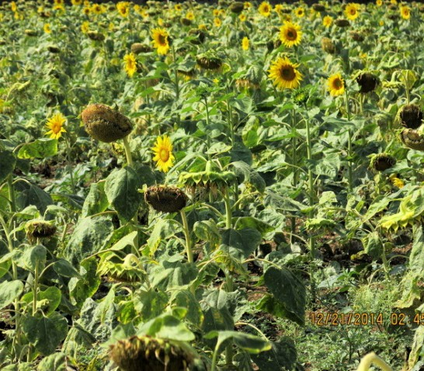
Agriculture
Currently the farm at City of Child supplies all the grain required at City of Child. The farm also provides approximately 25-30% of the vegetables needed. Fruit orchards help supplement the children’s diet. Produce left over after fulfilling the children’s needs is sold to generate income for the City of Child.
The children are encouraged to spend time on the farm with the farmer. The children’s enthusiasm is evident in them often volunteering to be part of diﬀerent farming activities.
With the help of funds received from the Sandy Wood Memorial Fund, plans are underway to design and build a hydroponic structure or covered farm. An initial study
will be conducted to determine the feasibility and scalability of this type of farming. Part of this initial trial will be a permanent structure of 250-500 square yards. If the trial works well, it will provide more produce than the same area will do with regular farming. Deep Griha Society is expecting a successful outcome and is hopeful of building an expanded hydroponic structure.

Key Updates for 2023:

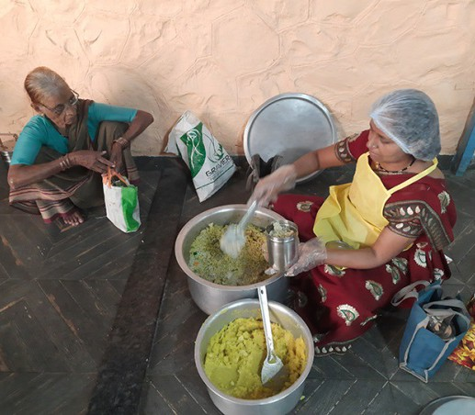
Upgraded Kitchen
The First Community Church Mission Council donation in 2022 to modify Deep Griha’s outdoor kitchen and eating area at the Tadiwala road Centre was completed in the first quarter of 2023 and is providing a modern environment to serve meals and as a drop- in center for the Senior Citizens they work with. Ashlesha passes on her many thanks to all who contributed to the First Community Church Mission and made this project possible.

Improve Screening for Postpartum Diabetes in Urban Slums of India
An exciting new initiative is the start of a study centered around Postpartum Diabetes in Urban Slums of India. DGS is conducting the study in collaboration with King Edward Memorial Hospital, Pune and Weill Cornell Medicine, New York. The aim is to determine if community health workers can improve screening and diagnosis of diabetes in pregnant and postpartum women in urban slum communities in India.

Healthy Aging (Viddha Mitra)
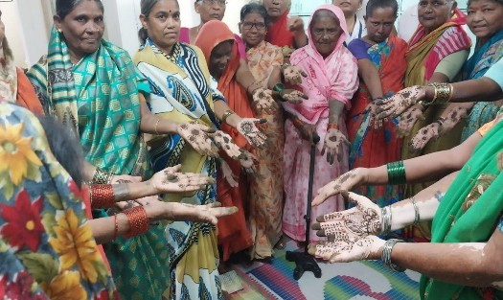
In late 2022 Deep Griha Society along with local Non-profit partners embarked on a new ambitious program to provide comprehensive elderly care. Over 4200 senior citizens are enrolled in the program. The program conducted home visits, regular general clinics, provided access to specialists in healthcare, physiotherapy, operations when needed, and medication. Grocery parcels were also distributed.
At the two centers at Tadiwala Road and Ramtekdi, daily meals for up to 100 people were provided. Daily yoga classes at the Ramtekdi Centre, and weekly classes at the Tadiwala road center were started. Dance therapy/Movement classes for all once a week at both the centers.

From the Desk of DGUSA
As always, we treasure your continued commitment to Deep Griha and the work being done there. It continues to be a challenging time for all of us, but even more for those who were already suﬀering greatly even prior to the Pandemic. We ask you to prayerfully consider how you may be able to assist in the work being done by Ashlesha and many others to improve the lives of the families and children there.
Please make your contributions directly through the website: deepgrihausa.org. Or if you prefer, send your check made payable to Deep Griha to: Barb Anderson, 8952 Tartan Fields Dr., Dublin, OH 43017
Make note on the memo line of the check where your contribution is to be directed: Example - “Sandy Wood Memorial,” “Area of Greatest Needs,” Aadhar Kendra Scholarship” or any other specific DGS program.
Look for more information in the upcoming months regarding the Spring 2024 event.
We pray that you will have good health and blessings during the coming year and that you will continue to share in the vision and mission of Deep Griha.

