Deep Griha Society
“Empowerment of the marginalised through capacity building and sustainable rural and urban development programmes”

Quarterly Report
April to June 2023

Key Advancements/Highlights Key Challenges faced

General Programme Updates
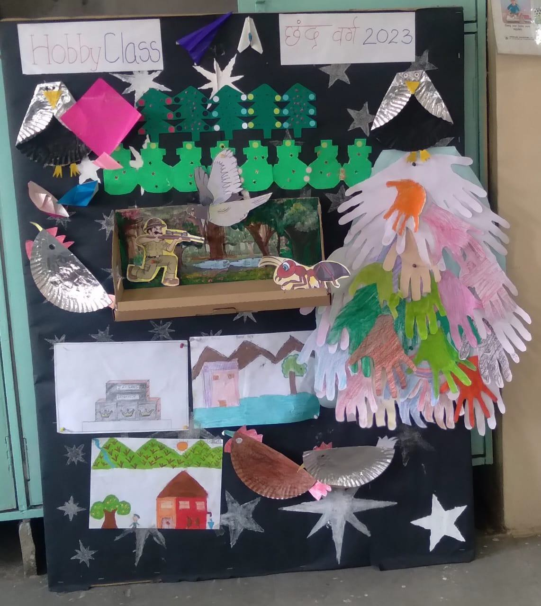
Aadhar Kendra Sponsorship Programme

The number of children stands at 272 at the end of this quarter. We have been working on enrolling new students, we intend to take it slow so that we can work on getting new sponsors for the students. 220 of the 272 have regular sponsors. 1450 meals were provided to the students over the months.
The children finished their academic year mid-April and the team organised Hobby Classes in the last week of April. The Hobby Classes include arts and crafts, games and other fun activities. We had a number of children attend the summer classes at FWC, JDP and DAK.

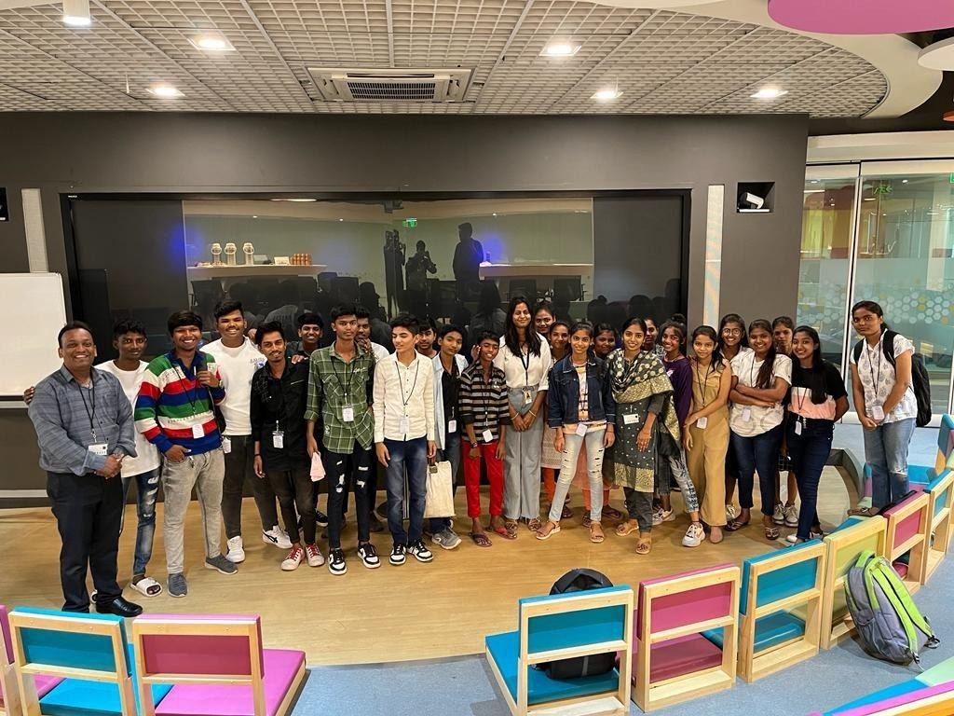
The Counsellor conducted a session on Personality Development, one that included tips on good communication as well as tips to deal with difficult situations. The students responded very positively to these sessions.

BNY Mellon, one of our CSR partners, conducted a Computer Class camp at their office in May for over 20 children where the students were introduced to MS Office, basic HTML and basic Python language as well. 7 of the 20 students won a gift hamper too.

City of Child

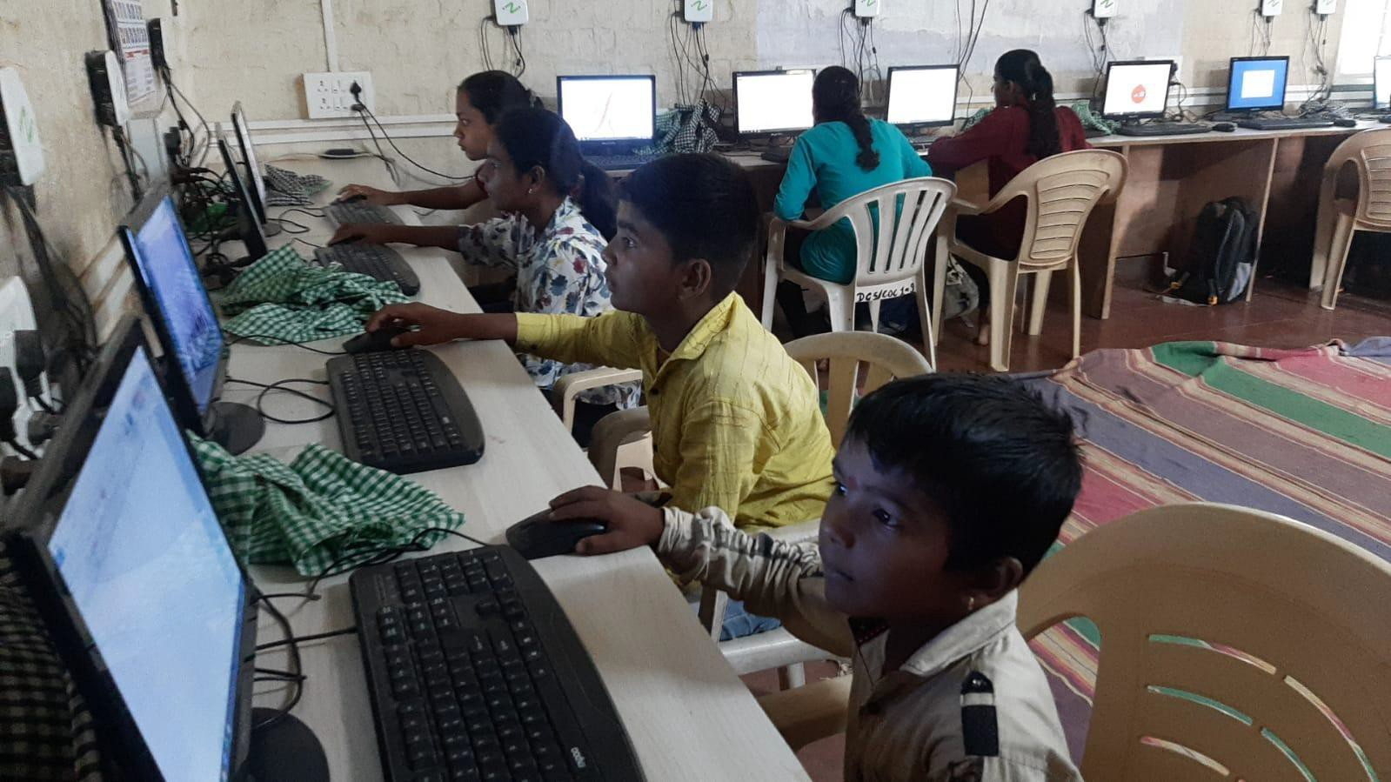
This Quarter covers the end of the academic year and the beginning of the new one, we had 39 students with 11 new admissions. Out of the 50 students we expect the number to change as some of the new students have never attended school and are struggling with being at CoC and we have more applications from students seeking admission.

Through the summer break, while our students had gone home for the summer, we conducted computer classes for young people from the villages around CoC. We had 18 students attend classes regularly for a month. Long enough to cover the basics.

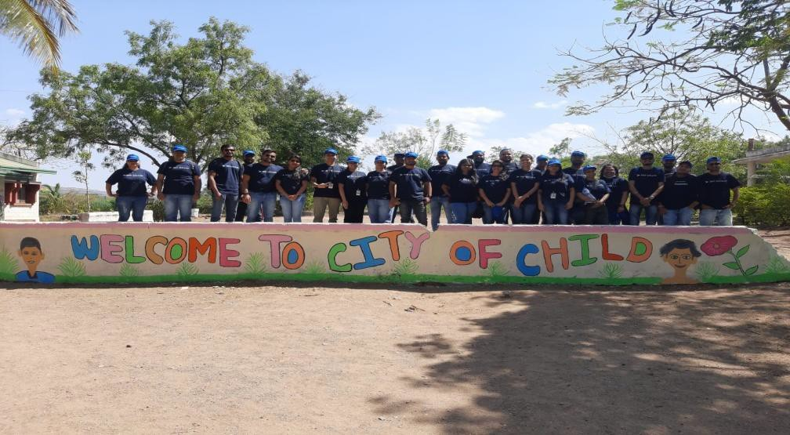
After a long break we were able to plan employee engagement activities with corporate offices that support us through CSR (Corporate Social Responsibility). One of the activities was painting of the common spaces at CoC, which the employees enjoyed thoroughly and has definitely brightened the premises for the students. The visiting employees also took part in the monthly birthday celebrations with the children.

The local support that CoC received through the pandemic continues into this year, where we have local sponsors donating as per their individual abilities, from blankets to groceries and even fruit from a local fruit seller. Increased local engagement through CSR and through local donors has been helpful to CoC to create more opportunities for the students and provides exposure that is crucial for social and personal development.

Whether it is students returning from time at home or new students enrolled at CoC, it is a challenging time for the team. This year, we have support from a Counsellor who will be working at DGA twice a week as a Special Educator and will work with CoC children in the evenings. We are working on a proposal for more counselling support for the students through the year as well.

Deep Griha Academy

The numbers have dropped drastically this year to 222, with 22 new admissions and 66 children who have passed out of school or dropped out for various reasons. Due to school permissions and challenges around that, we have seen a loss in the number of students at school.

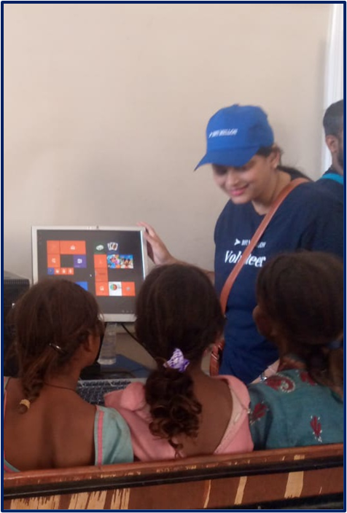
With a focus on our goal to ensure access to quality education for young children in rural areas, we are working towards reaching out to more children outside of school. So that access to quality education through the various resources that the school has, continues to reach young children whether they are part of the school or not.

In an effort to share school resources with children who aren’t enrolled at DGA, we conducted a two day Summer camp for children who live near the school. We had 87 children who participated in the activities which included a computer lesson, probably the first time a lot of the children got their hands on a computer. Educational activities were planned for the children, along with Karate lessons and access to the Library and playground. We plan to continue access to computer classes and the Library, for children who aren’t enrolled at DGA, through the academic year.

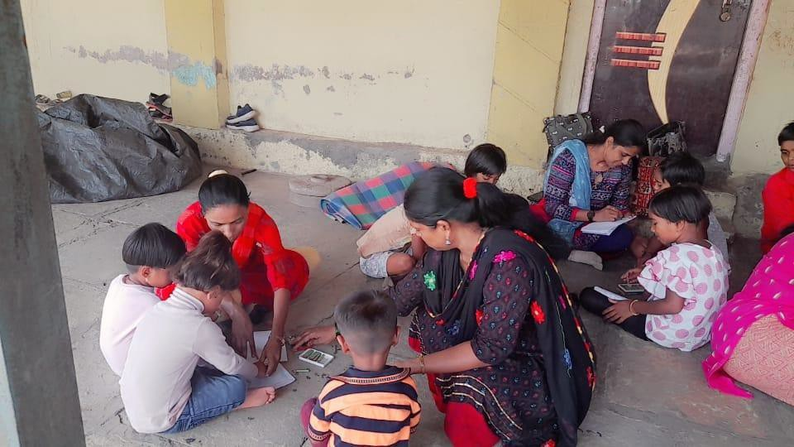
Apart from the summer camp, Teachers conducted activities to strengthen mathematical skills, fun games and a storytelling session in villages around the school. For most of the children, activity based learning is an unusual experience. We are aware that there is a limit on the number of children we can reach through the school and community outreach activities like these allow us to have a wider reach among young children. It is also where we can share the amazing resources we have.

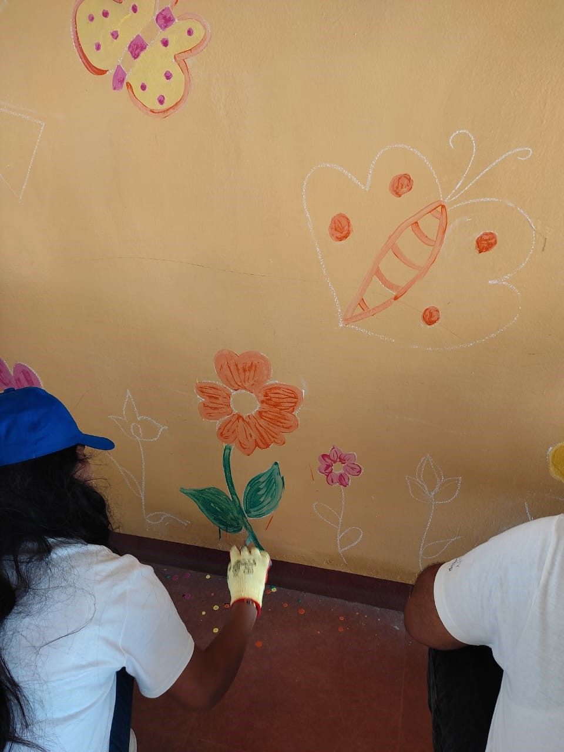
Employee Engagement activities are an important component when it comes to access to Corporate Social Responsibility (CSR) funds from companies. We have been able to go back to in-person engagement only this year and we had multiple events planned through this quarter, where the volunteers helped us to paint the pre-school building and other common areas at school, with fun colours. The volunteers also helped set up the library and the Science and Math laboratories.

Dream Proposal to Pilot Project Special Education
This was part of our Dream Proposals in the last report, and we have been able to start this program in a very small way at Deep Griha Academy. Over the years, true to its goal of being an inclusive learning environment, DGA has accepted admissions of children with different learning abilities, and the school’s reputation as a school that provides special education grew.

Nidhi Gandhi worked with Deep Griha Academy through Connecting NGO and was keen to spend more time with DGA; the teachers and students. Nidhi is a Special Educator and at the start of the academic year in June she started spending two days a week at school, with students who need special attention. She will be working with a member of staff from DGA, to build capacity within DGA to conduct special classes through the week.

We are excited to have this dream proposal have a small start, like a pilot project almost, one that will help us raise funds for a bigger intervention in the future.

Vriddha Mitra / Healthy Aging

This quarter began with 5 new Community Officers (CO) in the Ramtekdi and 3 new COs in Tadiwala road communities, young women from the community who will support the Senior Citizens in the community through access to medical care, conversations and any other support as required by individuals. We have moved into a neighbouring community as well with a new CO who started work there in June 2023. We now have a team of 10 COs, managed by 2 Cluster Coordinators, overseen by a Project In-charge, and together we will engage with 4000 Senior Citizens collectively, in both the communities.

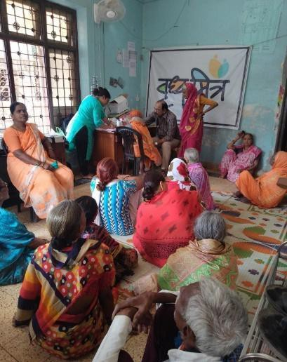
Apart from aspects of the project that are already funded through Azim Premji Foundation, we continue to raise funds for medicines, diapers, mobility assist devices and to meet various other needs. The team has reached out to local authorities and
private as well as Government hospitals for help with the medication.

In this Quarter we have collaborated with other organisations to distribute groceries where required, Health Check-Up camps, awareness on mental wellness, Eye check-up camp followed by cataract operations for 23 individuals, 38 general health checks with participation from 805 individuals, a Dental check-up camp and Physiotherapy access for 143 participants.

We have CSR support that we will be using for the daily meals that we continue to provide to individuals, the dance/movement classes and to add Physiotherapy equipment to the drop -in centres. We want to create a place where our Ajjis and Ajobas (Grandmothers and Grandfathers) can come: for lunch, information, a fun activity or a chat.

Income Generation Programme (IGP) - Asimit (Without boundary)
The focus for the women through the last year has been on Catering and the Tiffin service, where lunch and dinner is provided to individuals. The tiffin service started with 30 orders per month in January, and in June we provided 966 tiffins to vendors, office goers and security personnel at offices in the vicinity.

Through the Quarter we have collected information from women in the community about skills they would like to learn. We will facilitate access to the courses that the women want and supplement the learning with classes implemented by the Asimit team on finances, business, Google Suite, social media for business among other learning to prepare women to use the skills for income generation.

Tech SMART Centre, Gokhale Nagar

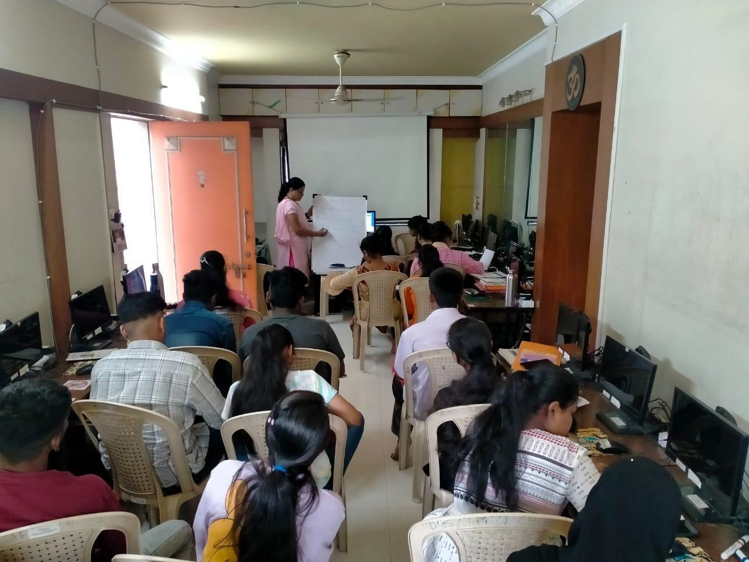
The Tech SMART Centre opened their doors in this quarter at their new premises in Gokhale Nagar, a part of Pune that Deep Griha has not worked in before.

The team did not have enough time for mobilisation as the location was finalised about a week before we were to open the doors, and yet we were able to get in 83 students to enroll in the class.

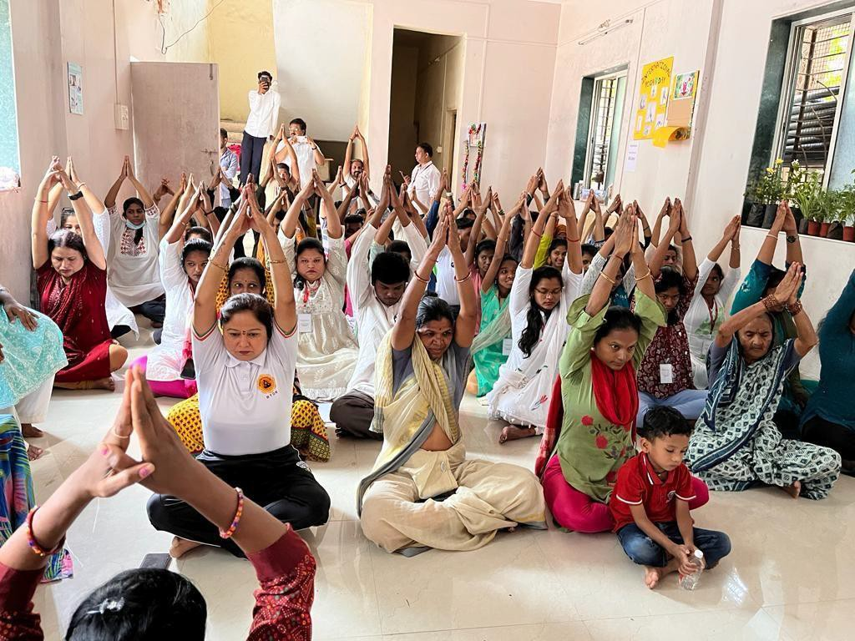
The team has been looking at various ways to build a rapport with the community, one of them was to celebrate Yoga Day followed by a Health Check-up camp.

As for the last location and last year’s numbers, our placement reached 67%, a tough task for the Placement Officer considering we had to move out of the last community for the lack of response.

Scholarship Programme – BNY Mellon
We received 207 applications for the Scholarship and through an interview process 96 students were selected for the scholarship. Family income, performance in the last exams are some of the considerations during the interview process. Once the selection process is complete the scholarships will be paid out to the selected candidates.

Special Project Updates Dream Proposals
CoC compound/enclosure
As a residential facility, CoC is required to have an enclosure and we have a wired fence surrounding the premises, the idea is to build a stronger compound structure for better security.

Residential facility for girls

Areas of Greatest Need/General Donations
The funds Deep Griha receives through ‘areas of greatest need’ and ‘general donations’ often support aspects of work that make all of our interventions and programme activities possible. In this quarter the amount was used for Property Taxes and Insurance, with a portion set aside for the Marketing needs for IGP, an expense that is not covered in the original proposal that funds the programme at this moment.

