Deep Griha Society
“Empowerment of the marginalised through capacity building and sustainable rural and urban development programmes”
Quarterly Report
April to June 2022

Key Advancements for April to June 2022
DGS received our official approval for FCRA (Foreign Contribution Regulation Act) for another five years. This regulation allows NGO’s like DGS to receive foreign funds to support their operation.
The Ramtekdi center had to be shut down after a structural audit declared the building unsafe. Over this quarter, the renovation of the center was finally completed and we can expand work that we do at the center. The renovation included added support for the 1st floor, new flooring for the first floor, and changes around the ground floor to include the support beams. We have a large space upstairs where we can begin computer classes for young children.
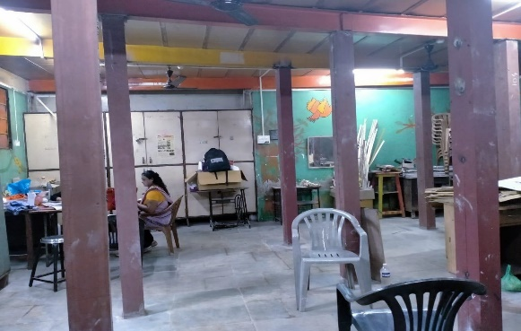
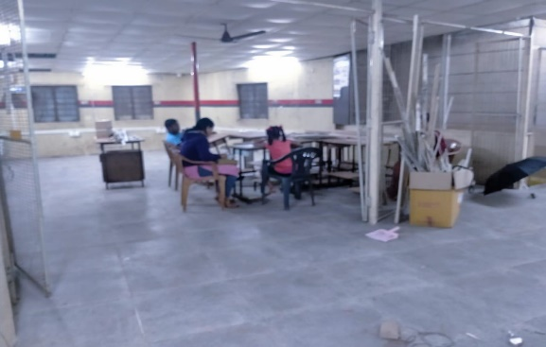

In the pipeline - A digital literacy center and Dental clinic will open at Ramtekdi in the new quarter.

Key Challenges faced
Getting funding for the renovation of the Ramtekdi building was a challenge. We still need to fundraise for part of the building as only half of it was funded and new requirements came to the fore once work began. We also need to raise funds for the painting.

General Program Updates
Aadhar Kendra Sponsorship Program
- Sessions on coding were organized at Ramtekdi center on alternate Saturdays. 7 children 5 girls and 2 boys attended the sessions. As a wonderful side effect, these sessions helped the children focus better and they have been able to concentrate on tasks better than they did when they first started.

- This year, apart from working on the holistic development of the children in the sponsorship program, the team will be working closely with the families, particularly mothers. The idea is to strengthen the mother: financially, healthcare wise and also through more awareness sessions as per requirement and request.

- This quarter to raise awareness around the importance of healthcare and also to build financial resilience, a session on the importance of health insurance was organized for Aadhar Kendra mothers/parents. Dr. Nikita Bankar, a medical doctor was the resource person, who explained in detail the benefits of opting for insurance and also helped clear any misconceptions/fears the women had regarding the same. On a side note, health concerns are high on the list of unexpected costs that lead to borrowing money from various resources. Insurance will help with these unexpected costs.

- 31 New children (16 Girls and 15 boys) were enrolled from April to June 2022 from all the 3 urban centers. 30 children are on the waiting list and need sponsors.
5 children were dropped from the program. 2 children have completed their education and have started working (1 is working as an assistant in a private bank and the other one works in Ruby hospital both earn Rs 10,000 to Rs 12,000 (USD 125- 150 or GBP 105 to 125 per month) , 2 children left the area where we provide service and are not reachable, and 1 has dropped out of school/college.

- 264 children from the urban center are presently being supported through the Aadhar Kendra sponsorship program. More than 200 children received one meal a day at all the centers.

- Around 75 children from the 2 centers underwent medical checkup. Children identified with health concerns are being monitored.

City of Child
9 students finished their Grade 10 exams and will be moving out of CoC for further studies. We have 1 new admission, and 3 in process, bringing the current number of children up to
39. The idea is to get more admissions so that we have 50 boys at CoC in the new quarter.

We had 23 students who stayed at CoC through the summer break, children who don’t have a stable home to go back to, for the holidays as well as new children who came to CoC through another organization called Rainbow Homes. The team planned a lot of fun summer activities throughout the holidays. For one week the children came to the Deep Griha Cultural Centre for activities by the Pune based AK team, the children had fun but missed the open spaces at CoC and were happy to go back home.

After a two-year break, we had volunteers from Audencia, in France come back to spend time at CoC. The group of 12 students arrived mid-June and will be at CoC till August.
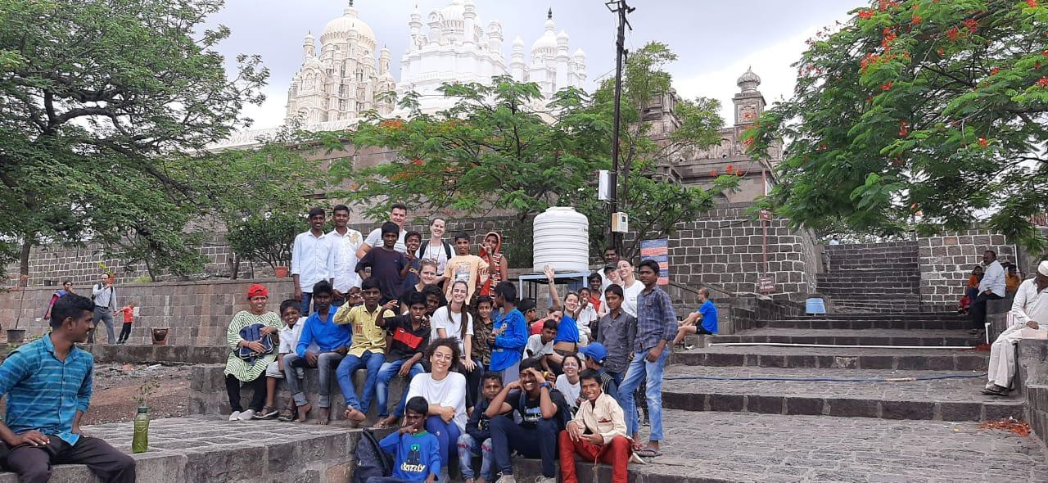
Both groups are very happy to be spending time with each other and getting to know each other. The team plans activities with the children for the weekend and even some exposure visits and hikes.

Deep Griha Academy
April saw the academic year wrapped up with evaluations, assessments and reports. Since classes were done for the year, April also saw 2 community outreach activities. The activities reached out to about 60 children living around the school. Children who do not have access to the teaching methods, tools or resources that students at DGA have. Learning through fun activities is almost a privilege that many children don’t have access to, and these outreach activities make an effort to bring this form of learning to children who are not enrolled at DGA.
The month of May hosted a short and sweet summer camp for children who live around the school. Around 70 children participated in language enrichment activities, story telling, dance, art and craft, music, yoga and games. Over 40 students from a factory near school and 20 children from CoC participated in this summer camp.

DGA has a few corporate sponsorships that keep the school running, as we are far from being financially sustainable. One of the companies that has been supporting the school for a few years now, donated new laptops to all the teachers. This donation will allow teachers to access more resources and include audio visual learning beyond what has been possible so far. The new laptops will help us contain the use of paper, a step in the right direction for environmental consciousness.

June 13, 2022 the school began the new academic year. The teachers planned fun activities to welcome the children back after the summer break. We have our fingers crossed that we are able to have offline classes for the whole academic year.

Healthy Aging
SCHOOL the organization is working on a proposal for a large grant along with 4 or 5 other NGOs working with them on the healthy ageing project. The initial proposal was to work on documents required to access Government funds available to senior citizens and people in need. During the initial discussions, the donor representative has asked for a comprehensive program plan, which SCHOOL is working on, along with Deep Griha and other NGOs.
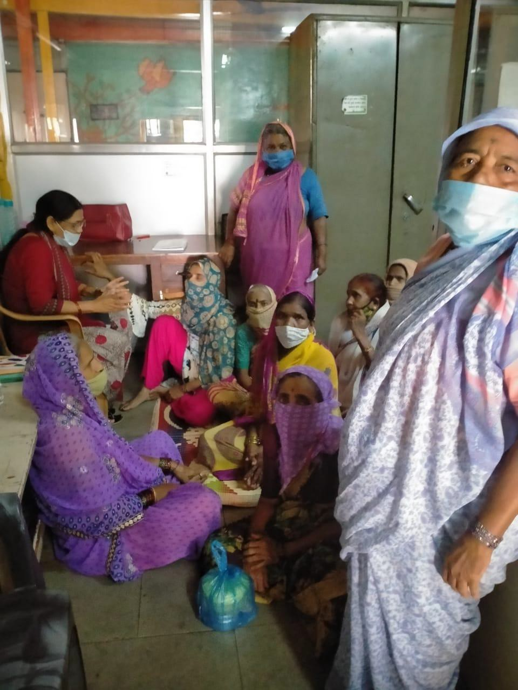
Apart from a SCHOOL requirement, DGS has been organizing informal conversations with members from the community to try and come up with activities for this age group. In our experience so far, conversations and listening have been fabulous for this group as well.

Legal Aid Centre
Over the years, Deep Griha Society and ILS Law College in Pune, have been bringing legal advice to women from the community with regards to domestic violence, property issues and other challenges faced by women in the community. An activity that had to stop over the last two years and started again in this quarter.

Philanthropic Grant – BNY Mellon WorkForce Development Scholarships Project 2021
- 22
We have been distributing scholarships to students enrolled in vocational courses, or courses that lead to immediate employment including Nursing, Technical studies among others. We have received USD 30,000 for this year and through this quarter we have been accepting applications as well as conducting interviews with the candidates to help choose eligible candidates for the scholarship. 191 candidates have been interviewed from 261 applications.

Income Generation Program (IGP)
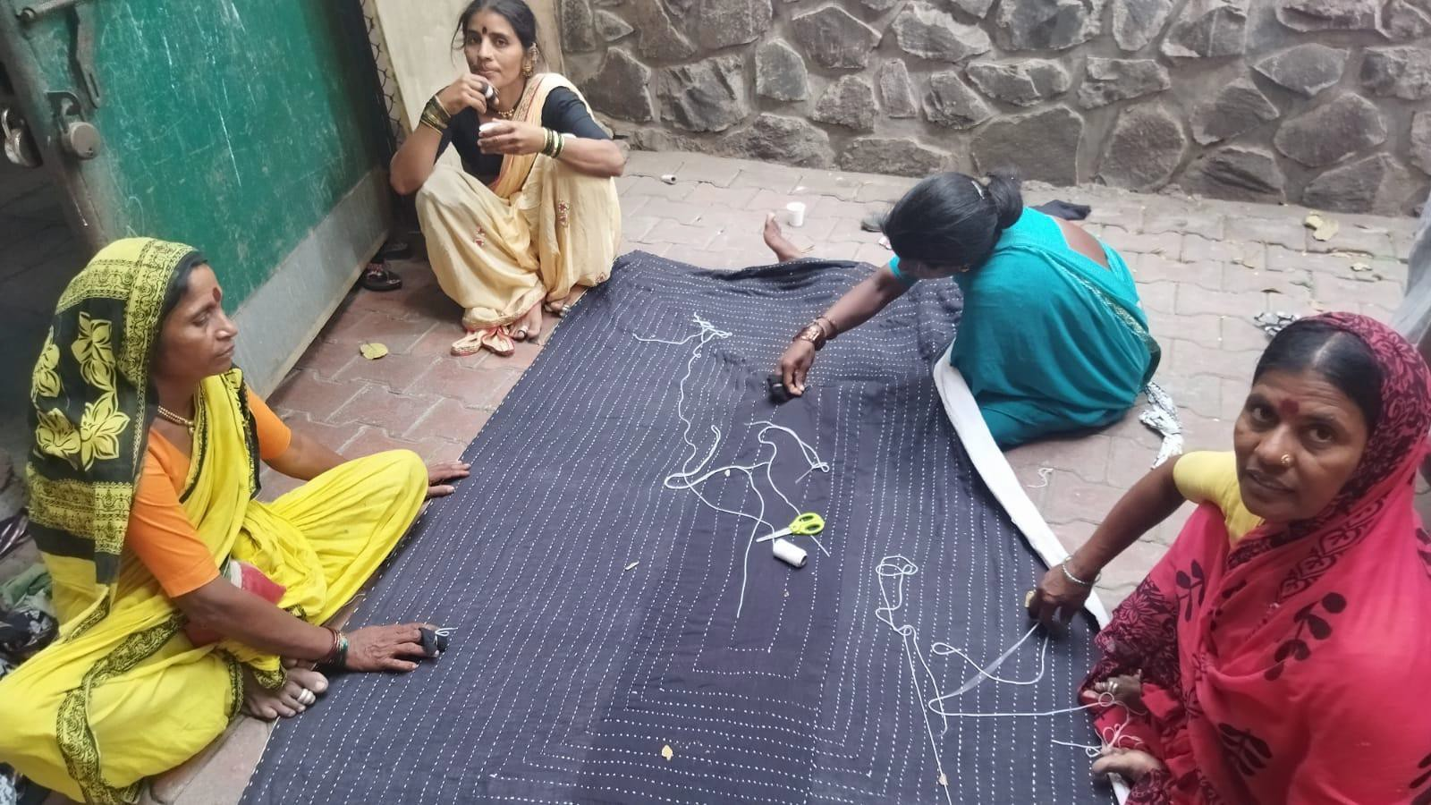
The number of women, signed up for IGP has gone up by 10 to 53 now. The women have served over 6000 meals in this quarter, including Aadhar Kendra meals, meals for senior citizens as well as catering orders. New quilt orders came in as well, once again using sarees.
The team has been working on marketing and new products. They have recently started an initiative where they provide presents to an office for their team members - this month the team provided indoor plants.

Tech SMART Centres - Ramtekdi and Gultekdi
The Tech SMART center at Gultekdi was able to achieve 70% placement for students from 2021-2022, despite lockdown challenges at the beginning of the year. Their new year is off to a good start as well.
Tech SMART center, Ramtekdi has moved back to Tadiwala road for the first quarter of this financial year. They have had a great response from the students through this quarter.. Along with classes at Tadiwala road, we had a feasibility study to help us choose a new location for the Tech SMART center. At the end of June we were able to decide on a new location for the center, and the beginning of the next quarter will focus on making the move finally in August 2022.

Specific Areas of Funding requested from Dublin Community Church

By Clicking on the following link: https://www.deepgrihausa.org/
You will have the opportunity to select “Donation” and select the area that you would like to support. “Area of Greatest Need” is a 100% donation to DGS that will be proportioned to the area of DGS that needs assistance immediately. “Sponsor a Child” will provide much needed support of the Aadhar Kendra Sponsorship Program.

Reminder: Deep Griha is supported by the DUCC Mission Committee and the October Second Mile Giving campaign specifically supports DGS.

VOLUNTEERS NEEDED
Deep Griha are on the lookout for two volunteers who can be based anywhere in the world! The first
role is someone to help them keep their website up to date and has knowledge or experience of
using WordPress. The second opportunity is for someone who would be able to help Deep Griha
develop an online marketing strategy and has experience in Google Adwords. Brief role descriptions
for these two roles are included below, please do have a look at them and share with others. If you
are interested or have any questions please contact Rahul Chauhan, Change Manager at Deep Griha
Society, rahulchauhan@deepgriha.org
Web Development volunteer
Deep Griha is looking for someone who can help them with making improvements to their website.
This isn’t about developing the website from scratch, instead improving the overall content of the
website, ensuring it is up to date and improving the ranking of the website. Activities will include
adding new pages and sections to pages including new/updated photos, testimonies and other
multimedia content.

Deep Griha will provide content to be uploaded, this may include news stories, updates of figures
e.g. the number of people who are part of the Aadhar Kendra program or new pages. The
content will need to be proofread before uploading and ensuring here is consistency across the site.

What skills do you need?
The Deep Griha Society website is hosted on WordPress, so someone who is confident in editing
content using WordPress along with setting up new pages, adding new sections to pages and adding
multimedia content. This role can be done online and so you can be based anywhere in the world!

What is the commitment?
Deep Griha are looking for someone who is able to commit around 10 hours per month on an
ongoing basis, though the amount of work will vary slightly on a month by month basis depending
on need. Your availability can be worked around in discussion with Deep Griha so if you are interested
but only have limited time, please do get in touch anyway to discuss what might be possible.

Who should I get in touch with if I am interested and would like to find out more?
Please get in touch with Rahul Chauhan, Change Manager at Deep Griha Society -
rahulchauhan@deepgriha.org Rahul will also be the main contact for this role.

Digital Marketing volunteer
Deep Griha are also looking for someone who can help them increase online awareness of Deep
Griha society. They don’t currently have a digital marketing plan, so would also appreciate guidance
and advice on the development of this to decide the best approach, which might include the use of
Google Ad campaigns.

What skills do you need?
Someone who has experience and knowledge in online marketing, the development of marketing
strategies/plans as well as skills in the use of Google Campaigns and Adwords. This role can be done
online and so you can be based anywhere in the world!

What is the commitment?
Deep Griha are looking for someone who is able to commit around 10 hours per month on an
ongoing basis, though the amount of work will vary slightly on a month by month basis depending
on need. Your availability can be worked around in discussion with Deep Griha so if you are interested
but only have limited time, please do get in touch anyway to discuss what might be possible.

Who should I get in touch with if I am interested and would like to find out more?
Please get in touch with Rahul Chauhan, Change Manager at Deep Griha Society -
rahulchauhan@deepgriha.org Rahul will also be the main contact for this role. Or Ken Bitter kcbitter77@gmail.com

